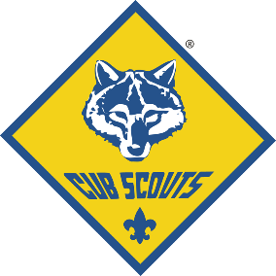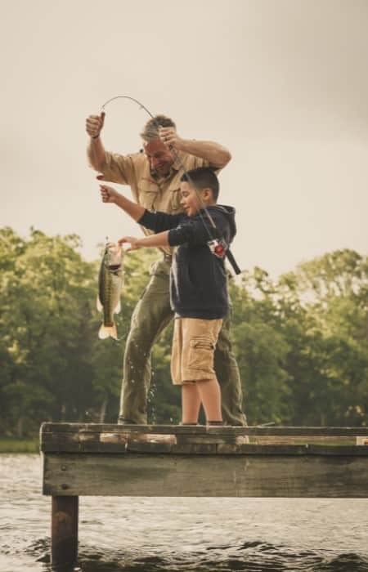

EXCITING PACK ACTIVITIES THIS FALL!

**Fishing Derby – Sept 12th!**

Fishing, Fun, Prizes, and your 1st patch! Learn how to fish! Poles, bait, and supplies will be provided. $10 a Scout. 9:00am to 12:00pm at Smith Lake Park!

**Cub Haunted Campout!**

Family Camping at Camp Comer! Hay rides, shooting sports, field games, haunted trials and much more! Fun for the whole family!

**Rain Gutter Regatta!**

This racing event is the sailboat equivalent of the pinewood derby. Build your model boat and then race it again other Scouts! Nov 19th!

Pack Activity Calendar 2020

August

25 – Tues. 1st - Pack Meeting

September

1 – Tues. Pack Popcorn Kick-off

8 – Tues. Den Meetings

15 – Tues. Den Meetings

22 – Tues. Pack Meeting

_________ Fishing Derby

October

6 – Tues. Den Meetings

13 – Tues. Den Meetings

20 – Tues. Pack Meeting

23 – 25 Cub Haunted Campout

26 – Mon. Popcorn Sale Ends

November

3 – Tues. Den Meetings

10 – Tues. Den Meetings

17 – Tues. Rain Gutter Regatta

December

1 – Tues. Den Meetings

8 – Tues. Den Meetings

15 – Tues. Christmas Party

PARENT ORIENTATION MEETING!

Learn everything you need to know for the upcoming program year! Free Cub Scout Handbooks will be handed out. Activities for your Scout(s) to do.

6:30pm on **Tuesday, August 20th**

at Oak Park School, 12345 Oak Park Drive

Huntsville AL

Pack Leadership Contact Information:

CUB MASTER: John Doe 555-555-5555 johndoe@gmail.com

COMMITTEE CHAIR: John Doe 555-555-5555 johndoe@gmail.com

Welcome to Pack 123!